Airlines Data Analytics for Avaition Industry

**Team ID**: PNT2022TMID28207

**Team Leader:** Bharath Kumar S

**Team member 1**: Aravindhan S

**Team member 2**: Dhanush V

**Team member 3:** Anirudh V

**Team member 4**: Dhakshnamoorthy B

# . INTRODUCTION

* 1. **Project Overview**

In the present world, the major components of any transportation system include passenger airline, cargo airline, and air traffic control system. With the passage of time, nations around the world have tried to evolve numerous techniques for improving the airline transportation system. This has brought a drastic change in airline operations. Flight delays occasionally cause inconvenience to modern passengers. Every year approximately 20% of airline flights are canceled or delayed, costing passengers more than 20 billion dollars in money and time.

* 1. **Purpose**

Average aircraft delay is regularly referred to as an indication of airport capacity. Flight delay is a prevailing problem in the world. It's very tough to explain the reason for the delay. A few factors responsible for the flight delays like runway construction and excessive traffic are rare, but bad weather seems to be a common cause. Some flights are delayed because of reactionary delays, due to the late arrival of the previous flight. It hurts airports, and airlines, and affects a company's marketing strategies as companies rely on customer loyalty to support their frequent flying programs.

# 2. LITERATURE SURVEY

1. **Towards a maturity model for big data analytics in airline network planning (Iris Hausladen, Maximilian Schosser -2020)**
   * In this study, **Iris Hausladen, Maximilian Schosser** address this challenge by developing a maturity model for big data readiness for airline network planning.
   * The transfer steps have been combined with the model evaluation. In the second stage, the maturity levels are conceptualized and formulated, before the complete model is evaluated by the practitioner group.
2. **Life Data Analytics with Application for the Airline Industry**

**(Julio Pulido, NortekDana Moore, William Hill -2020)**

* + In this study**, Julio Pulido, NortekDana Moore, William Hill** proposed the analysis of non-repairable systems.
  + The three techniques, namely the time to failure, stress-strength or condition-based approach, is generally adopted.
* The mixed Weibull distribution (also known as a multimodal Weibull) is used to model data that do not fall on a straight line on a Weibull probability plot.

1. **Exploratory Data Analysis on Aviation Dataset**

**(Saba Firdous, Haseeba Fathiya, Lipsa Sadath** -**2021)**

* + In this work, **Saba Firdous, Haseeba Fathiya, Lipsa Sadath** performed Aviation informational collection and performed analytics.
  + The first step was to organize all the events into categories depending on their risk level.
  + The next step was to use an SVM to learn the relationships between the events.
  + The third step was to combine the results from both models to improve the accuracy of the predictions made.

1. **Applying Machine Learning to Aviation Big Data for Flight Delay Prediction**

**(Yushan Jiang, Yushan Jiang -2020)**

* + In this study**, Yushan Jiang, and Yushan Jiang** developed several machine learning models to predict flight arrival delays.
  + Firstly data pre-processing is needed including data merging and cleansing.
  + Next, data visualization can be performed to extract and visualise the graphic representation of data clearly and efficiently.

1. **Transportation Research Part E IN Aviation**

**(Xu et al- 2020)**

* In this work, Xu et al proposed a hybrid model to forecast statistical indicators in the aviation industry, which employs the seasonal autoregressive integrated moving average (SARIMA) and support vector regression (SVR) methods**.**
* SARIMA is employed to analyze the raw time series. Gaussian White Noise is then used for calculation according to the SARIMA’s results.
  1. **References**

1. Iris Hausladen, Maximilian **Schosser “ *Towards a maturity model for big data analytics in airline network planning”,***

ELSEVIER-Journal of Air Transport Management, Volume 82,(2020).

1. Julio Pulido, NortekDana Moore, William Hill **“*Life Data Analysis with Applications for the Airline Industry* ”**, IEEE XPLORE-

**Published in** [2016](https://ieeexplore.ieee.org/xpl/conhome/7442973/proceeding) [Annual Reliability and Maintainability Symposium (RAMS)](https://ieeexplore.ieee.org/xpl/conhome/7442973/proceeding)

1. Saba Firdous, Haseeba Fathiya, Lipsa Sadath **“ *Exploratory Data Analysis on Aviation Dataset* ”**, IEEE XPLORE, Conferences-2021
2. Yushan Jiang, Yushan Jiang **“*Applying Machine Learning to Aviation Big Data for Flight Delay Prediction*”** IEEE XPLORE, Conferences -2021
3. Xu et al **“*Transportation Research Part E IN AVIATION*”**, SCIENCE DIRECT- Journals and books, Volume 167,(2022).
   1. **Problem Statement Definition**

Flight delays in air transportation are a major concern that has adverse effects on the economy, the passengers, and the aviation industry. This matter critically requires an accurate estimation for future flight delays that can be implemented to improve airport operations and customer satisfaction. Thus, we propose an interactive dashboard in which user can predict the delays if occurs.

To build a user interface application to analyze the delays so airports organizations can adjust and allocate the resources(airports) nearby quickly.

1. **IDEATION & PROPOSED SOLUTION**
   1. **Empathy Map Canvas**

An empathy map is a simple, easy-to-digest visual that captures knowledge about a user’s behaviours and attitudes.It is a useful tool to help teams better understand their users. Creating an effective solution requires understanding the true problem and the person who is experiencing it. The exercise of creating the map helps participants consider things from the user’s perspective along with his or her goals and challenges.

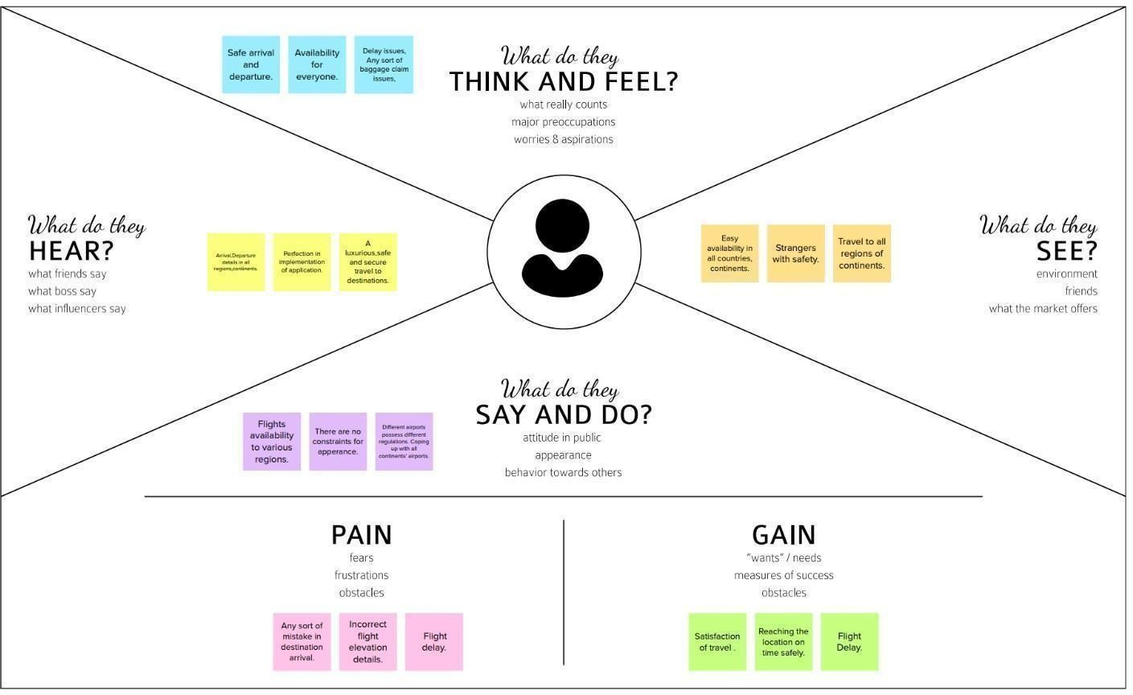

* 1. **Ideation and Brainstorming**

Brainstorming provides a free and open environment that encourages everyone within a team to participate in the creative thinking process that leads to problem-solving. Prioritizing volume over value, out-of-the-box ideas are welcome and built upon, and all participants are encouraged to collaborate, helping each other develop a rich amount of creative solutions.

Use this template in your own brainstorming sessions so your team can unleash their imagination and start shaping concepts even if you're not sitting in the same room.

* + 1. **Brainstorm, Idea Listing and Grouping**

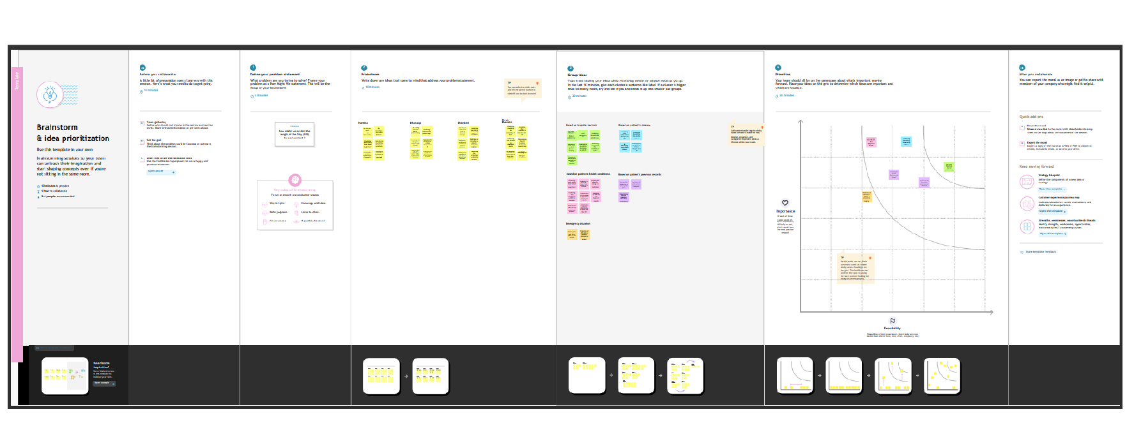

* + 1. **Idea Prioritization**

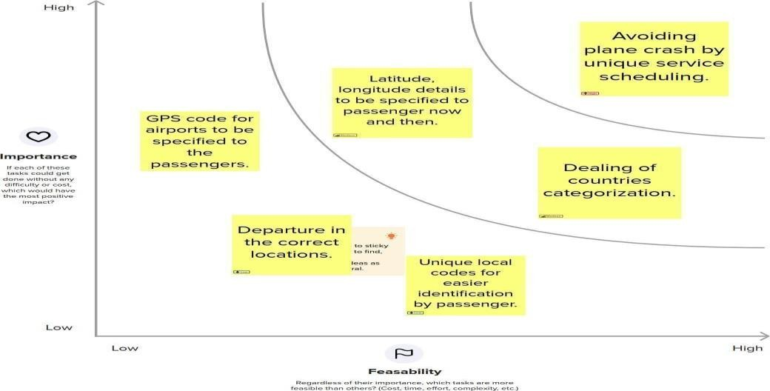

**3.4 Proposed Solution**

Project team shall fill in the following information in the proposed solution template

|  |  |  |
| --- | --- | --- |
| **S.N**  **o.** | **Parameter** | **Description** |

|  |  |  |
| --- | --- | --- |
| 1. | Problem Statement (Problem to be solved) | * Reduction of the causes of the flight delay. * With the growing demand for air transportation and the limited ability to increase capacity at some key points in the air transportation system, it is found to be difficult that in the future the system will not scale to meet demand. * This will result in the generation of delays throughout the system, impacting passengers’ travel and more broadly the economy. * Passengers not knowing the status will be solved |
| 2. | Idea / Solution description | * Grouping of the efficient data to reduce the delay of the travel period. * Traveler demand for specific city pairs and pricing flights can be done. * Airlines use this biometric technology as a boarding option.   The equipment scans  travellers’ faces and matches them with photos stored in border control agency databases. These can be handled. |

|  |  |  |
| --- | --- | --- |
| 3. | Novelty / Uniqueness | * The advantage of big data analytics includes timely responses to current and future market demands, improved planning and strategically aligned decision-making. * It also includes crystal clear comprehension and monitoring of all main performance drivers relevant to the airline industry. * Due to the use of smart data analytics, passengers will avoid many issues with baggage tracking. * While radiofrequency identification prevents mishandling the baggage, predictive analysis assists in improving   the predictability of fleet reliability. |
| 4. | Social Impact / Customer Satisfaction | * Passenger satisfaction is obtained. No passenger undergoes discomfort during travel or post or pr-travel traumas. * Data analytics helps the industry to understand customers’ preferences and other maintenance issues. |
|  |  | * As a result, by gathering meaningful data, airlines can fetch more bookings in the given timeframe. |

|  |  |  |
| --- | --- | --- |
| 5. | Business Model (Revenue Model) | * This solution can be implemented in various government and private sectors which helps enable predictive measures. * Innovation in airlines can contribute to the creation of value, competitive advantage and profitability with new possibilities of action. * A revenue model is a blueprint that shows how a startup business will earn revenue or gross income from its standard business   operations, and how it will pay for operating costs and expenses. |
| 6. | Scalability of the Solution | * This solution would be highly scalable for any platform implementation and application. * The Cloud Cognos Analytics is not only for organization/governments. * Aviation industry acting internationally, domestically, or privately is also getting satisfied with the aviation data analyzing process provided. |

**3.4 Problem Solution fit**

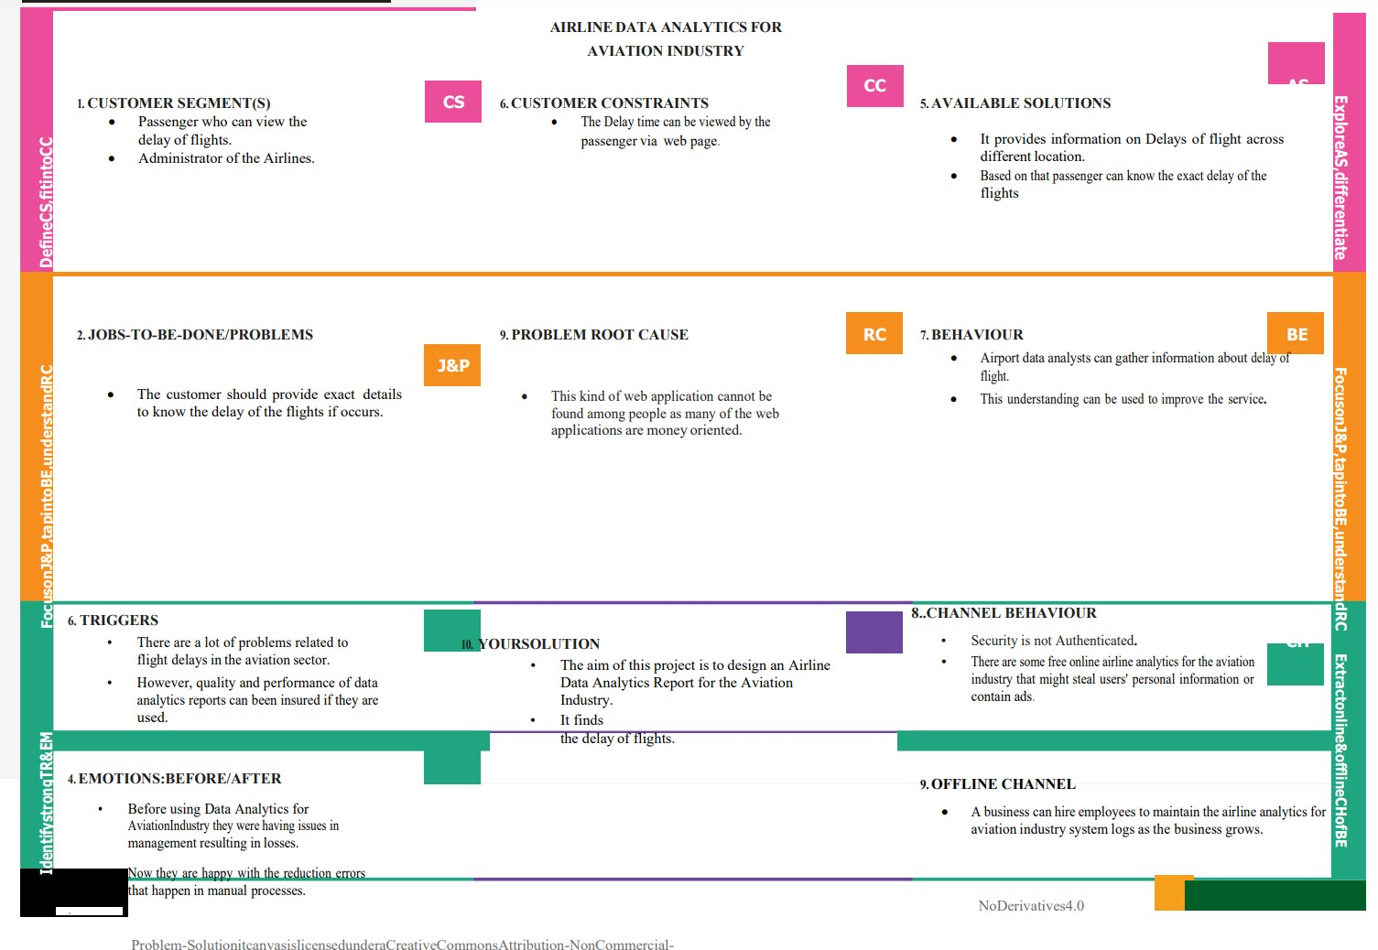

# REQUIREMENT ANALYSIS

* 1. **Functional requirements**

Following are the functional requirements of the proposed solution.

|  |  |  |
| --- | --- | --- |
| **FR No** | **Functional Requirement (Epic)** | **Sub Requirement (Story / Sub-Task)** |
| FR -1 | customer Registration | customer can make Registration through Gmail |
| FR-2 | User Confirmation | After the Registration the customer will get confirmation through the mail. |
| FR-3 | Visualizing data | User can visualize the Regular trends of delay of flights Using IBM Cognos Analytics |
| FR-4 | Generating Report | User can view the flight delay report |

* 1. **Non-Functional requirements**

Following are the non-functional requirements of the proposed solution.

|  |  |  |
| --- | --- | --- |
| **FR No.** | **Non-Functional Requirement** | **Description** |
| NFR-1 | **Usability** | The application will have a simple and user-friendly graphical interface. Users will be able to understand and use all the features of the application easily.  Any  action has to be performed with just a few clicks |

|  |  |  |
| --- | --- | --- |
| NFR-2 | **Security** | The main security concern is for users' accounts hence proper login mechanism should be used to avoid hacking. The organization system should not disclose the personal information of users and other organization details to the public. |
| NFR-3 | **Reliability** | When the system is disconnected or frozen due to over access at the same time, it should save all the process of the users made up to the point of abnormal happenings. |
| NFR-4 | **Performance** | The system should require a fair amount of speed, especially while browsing through the  catalogue. |
| NFR-5 | **Availability** | The system shall be available 24 hours a day 7 days a week. Users can access it at any time. |
| NFR-6 | **Scalability** | Large Number of users can access the website |

# PROJECT DESIGN

* 1. **Data Flow Diagrams**

A Data Flow Diagram (DFD) is a traditional visual representation of the information flows within a system. A neat and clear DFD can depict the right amount of the system requirement graphically. It shows how data enters and leaves the system, what changes the information, and where data is stored

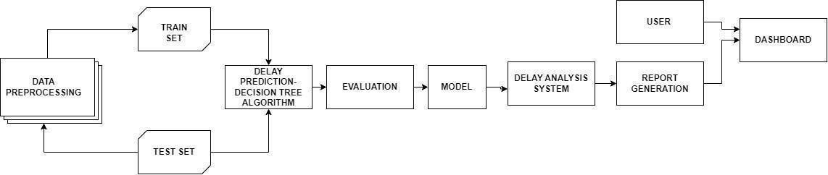

* 1. **User Stories**

Use the below template to list all the user stories for the product.

|  |  |  |  |  |  |  |
| --- | --- | --- | --- | --- | --- | --- |
| **User Type** | **Functional Requirement**  **(Epic)** | **User Story Number** | **User Story / Task** | **Acceptance criteria** | **Priority** | **Releas** |
| Customer (Web user) | Login | USN1 | * As a user, I can log into the application by entering my email & password. | I can get to access my web portal | High | Sprint- |
|  | Dashboard | USN-2 | * As a user, I can get to know how much time my flight’s delay is in. | I can get details of my registration. | Low | Sprint- |
| Customer Care Executive | Delay analysis | USN-3 | * Aviation industry which owns this aeroplane analysis system will enable the option to customers to reach out to the organization if there is any delay issue. * Prediction of delays is the main concept here. | The customer care workers will help the customers in trouble. | High | Sprint- |

* 1. **Solution & Technical Architecture**

|  |  |  |  |  |  |  |
| --- | --- | --- | --- | --- | --- | --- |
| Customer Care Executive | Delay analysis- Report generatio n | USN-4 | * The analyzed report is then sent to the airline's aviation industry for the customers to get to know the delay status. * The DGCA(Directorate General of Civil Aviation) will get to know the delays of flights and redirect safely with high customer safety. | The customer care workers will provide the users with the report. | Low | Sprint- |

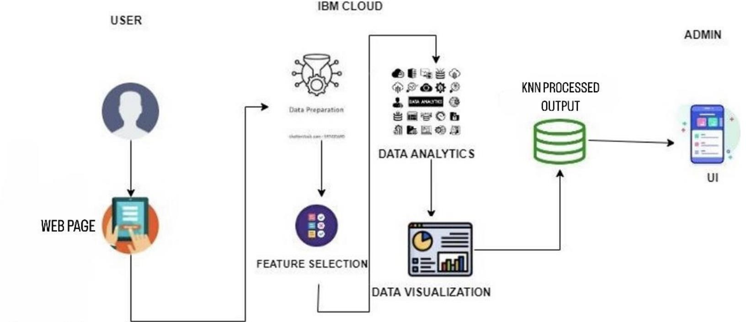

* 1. **User Stories**

**Table-1: Components & Technologies**:

|  |  |  |  |
| --- | --- | --- | --- |
| **N** | **Component** | **Description** | **Technology** |
|  | User Interface | User can Interact with web Applications | HTML, CSS,  JavaScript. |
|  | Data Preparation | Pre-processing of data should be done | Python |
|  | Feature Selection | Feature selection of the Dataset using the Correlation Feature Selection method. | Python |
|  | Data Analytics | Prediction of Flight delay using Decision Tree. | Python |
|  | Data Visualization | Data Type, Configurations etc. | Python |
|  | Data Storage | Database Service on Cloud | IBM DB2,  IBM Cloudant etc. |
|  | User Interface | Dashboard showing the details of the flight delay | HTML, CSS,  JavaScript. |

**Table 2: Application Characteristics**:

|  |  |  |  |
| --- | --- | --- | --- |
| **N** | **Characteristics** | **Description** | **Technology** |
|  | Security Implementations | The main security concern is for users’ accounts hence proper login mechanisms should be used to avoid  hacking. | e.g. SHA-256, Encryptions, IAM Controls, OWASP etc. |
|  | Availability | The system will be available 24 hours a day 7 days a week. Users can access it at any time. |  |

|  |  |  |  |
| --- | --- | --- | --- |
|  | Performance | The system should require a fair amount of speed, especially while browsing through the catalogue. |  |

# PROJECT PLANNING AND SCHEDULING

* 1. **Sprint Planning & Estimation**

|  |  |  |  |  |
| --- | --- | --- | --- | --- |
| Activity Name | Activity Number | Activity Description Tasks Assigned | | Status |
| Preparation Phase | 1 | 1. Access the resources in the project dashboard. 2. Explore the dataset provided in the workspace. 3. Create a GitHub account & collaborate with Project Repository in the project workspace. 4. Set up the prerequisites for the project. | BHARATH KUMAR S  ARAVINDHAN S  DHANUSH V  ANIRUDH V  Dhaksnamoorthy B | Completed |
| Ideation Phase | 2 | 1. Literature survey relevant to the selected project. 2. Preparation of an Empathy Map to identify the user pros and cons. | BHARATH KUMAR S  ARAVINDHAN S  DHANUSH V  ANIRUDH V  Dhaksnamoorthy B | Completed |

|  |  |  |  |  |  |
| --- | --- | --- | --- | --- | --- |
|  |  | | c) List the ideas by organizing the brainstorming session and prioritize the top 3 ideas based on their feasibility & importance. |  |  |
| **Project Design Phase-I** | | 3 |  |  |  |
| Proposed Solution | | 3.1 | Preparation of proposed solution | BHARATH KUMAR S  ARAVINDHAN S  DHANUSH V  ANIRUDH V  Dhaksnamoorthy B | Completed |
| document, which includes the |  |
| Problem statement, Idea |  |
| description, novelty, feasibility of |  |
| the idea, business model, social |  |
| impact and scalability of the |  |
| solution. |  |
| Problem SolutionFit | | 3.2 | Prepared problem solution fit document which has designed a value proposition that addresses the customers’ job, pros and cons to the particular application. | BHARATH KUMAR S  ARAVINDHAN S  DHANUSH V  ANIRUDH V  Dhaksnamoorthy B | Completed |
| Solution Architecture | | 3.3 | Develop effective architecture for the proposed solution which provides | BHARATH KUMAR S  ARAVINDHAN S  DHANUSH V  ANIRUDH V  Dhaksnamoorthy B | Completed |
| ground for application development |  |
| projects. |  |

|  |  |  |  |  |
| --- | --- | --- | --- | --- |
| **Project Design Phase-II** | 4 |  |  |  |
| Solution Requirements | 4.1 | Identify the Functional and Non- Functional requirements of the proposed solution. | BHARATH KUMAR S  ARAVINDHAN S  DHANUSH V  ANIRUDH V  Dhaksnamoorthy B | Completed |
| Customer Journey | 4.2 | Preparation of customer journey map to understand the user interactions which describes the stages that the customer experiences over time. | BHARATH KUMAR S  ARAVINDHAN S  DHANUSH V  ANIRUDH V  Dhaksnamoorthy B | Completed |
| Data Flow Diagram and User stories | 4.3 | Generate Data flow diagram for  the Project which maps out the | BHARATH KUMAR S  ARAVINDHAN S  DHANUSH V  ANIRUDH V  Dhaksnamoorthy B | Completed |
| flow of information for the |  |
| application. |  |
| Technology Architecture | 4.4 | Develop effective technical  architecture for the proposed solution | BHARATH KUMAR S  ARAVINDHAN S  DHANUSH V  ANIRUDH V  Dhaksnamoorthy B | Completed |
| which describes the logical software |  |
| and hardware capabilities that are |  |
| required to support the development |  |
| of |  |
| the application. |  |

|  |  |  |  |  |  |  |  |  |  |  |
| --- | --- | --- | --- | --- | --- | --- | --- | --- | --- | --- |
| **Project Planning Phase** | | 5 |  | | | | |  | |  |
| Milestones  Activity List | & | 5.1 | Prepare Milestone and Activity list of the project. | | | | | BHARATH KUMAR S  ARAVINDHAN S  DHANUSH V  ANIRUDH V  Dhaksnamoorthy B | . | Completed |
|  |  | |
|  |  | + |  |
| Sprint Plan | | 5.2 | Prepare Sprint Delivery plan of the project | | | | | BHARATH KUMAR S  ARAVINDHAN S  DHANUSH V  ANIRUDH V  Dhaksnamoorthy B | | Completed |
| **Project Development** | | 6 |  | | | | |  | |  |
| Delivery of Sprint-1 | | 6.1 | Implement Sprint-1 | the | coding | phase | of | BHARATH KUMAR S  ARAVINDHAN S  DHANUSH V  ANIRUDH V  Dhaksnamoorthy B | | In Progress |
| Delivery of Sprint-2 | | 6.2 | Implement Sprint- 2 | the | coding | phase | of | BHARATH KUMAR S  ARAVINDHAN S  DHANUSH V  ANIRUDH V  Dhaksnamoorthy B | | In Progress |

|  |  |  |  |  |  |  |  |  |
| --- | --- | --- | --- | --- | --- | --- | --- | --- |
| Delivery of Sprint-3 | 6.3 | Implement Sprint-3 | the | coding | phase | of | BHARATH KUMAR S  ARAVINDHAN S  DHANUSH V  ANIRUDH V  Dhaksnamoorthy B | In Progress |
| Delivery of Sprint-4 | 6.4 | Implement Sprint-4 | the | coding | phase | of | BHARATH KUMAR S  ARAVINDHAN S  DHANUSH V  ANIRUDH V  Dhaksnamoorthy B | In Progress |

* 1. **Sprint Delivery Schedule**

A milestone schedule, or milestone chart, is a timeline that uses milestones to divide a project schedule into major phases. A milestone chart is a way to visualize the most important steps of our project. Each milestone the team achieves brings us closer to completing the project. As a result, milestones provide a sense of accomplishment and show the team how the work they’re doing contributes to the overarching project objective.

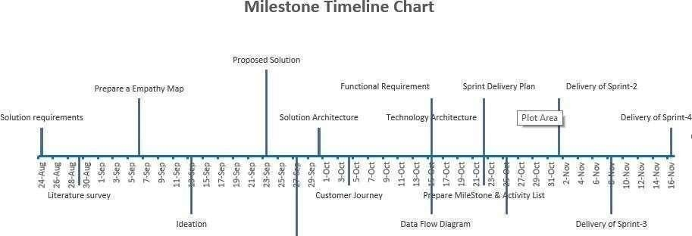

# REPORT FROM JIRA

**Project RoadMap**

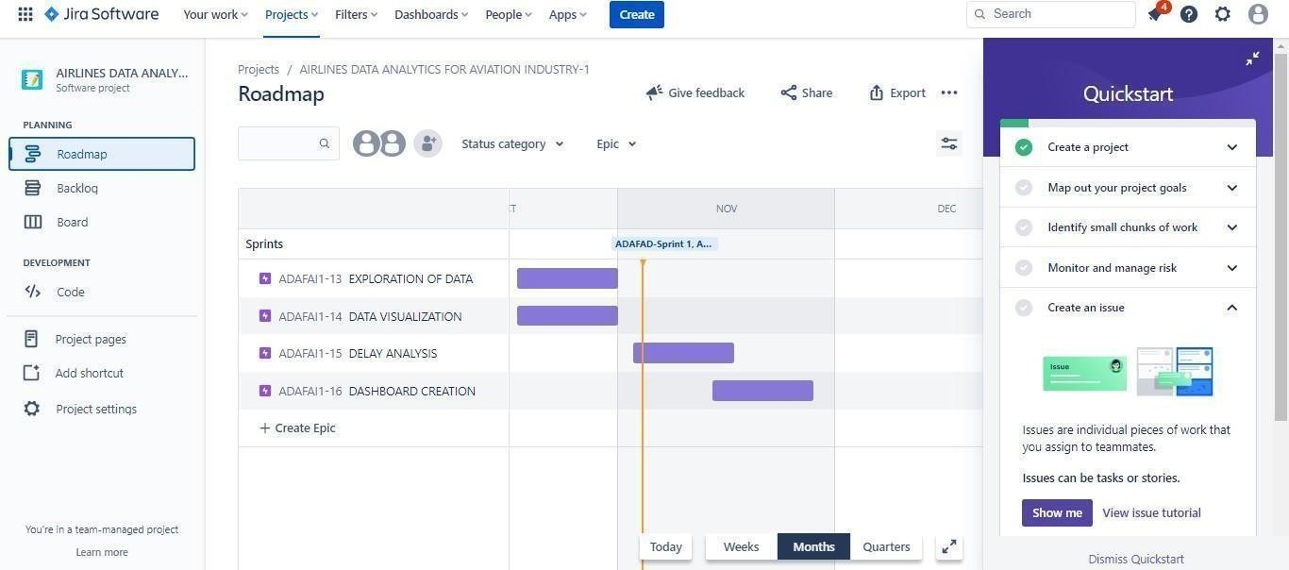

**Project Backlog**

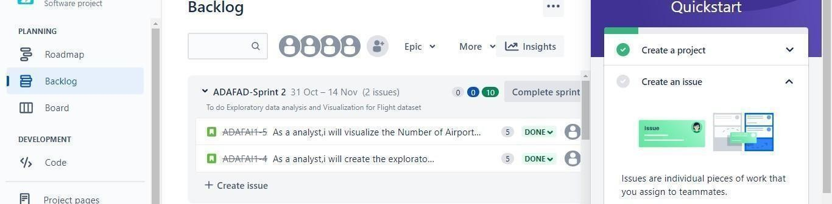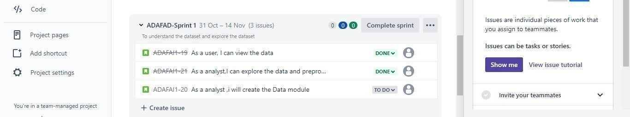

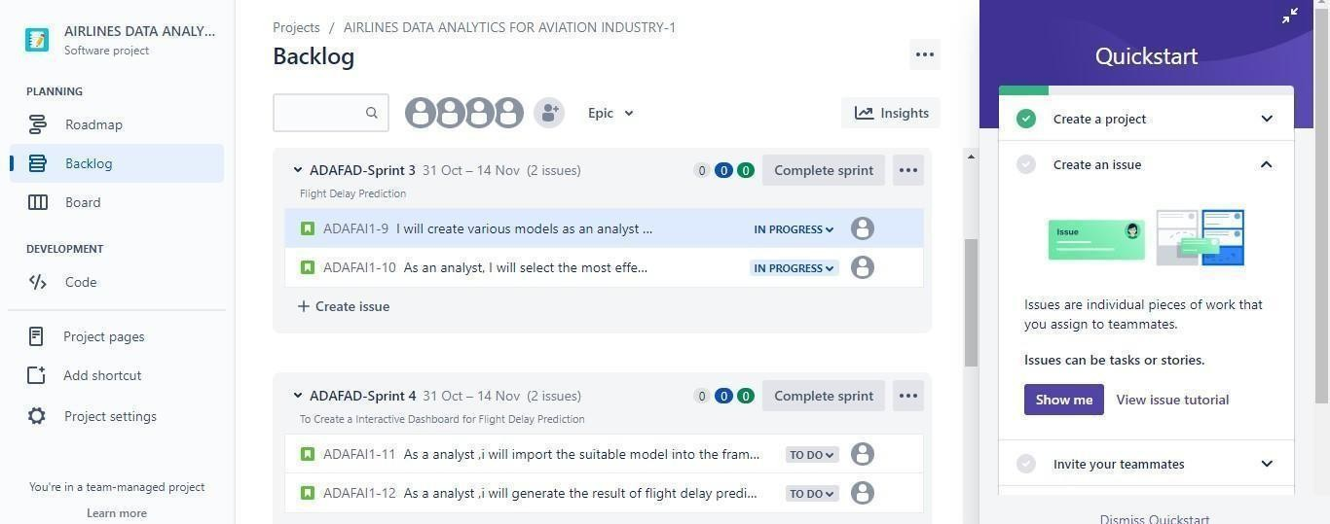

**Board**

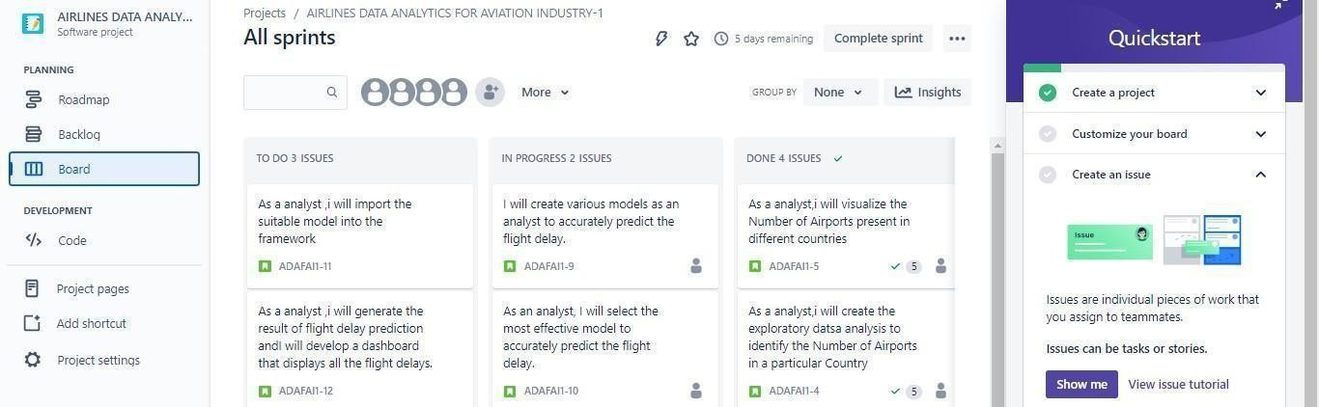

# CODING & SOLUTIONING (Explain the features added in the project along with code)

* 1. **Feature 1**

The user can enter the Elevation feet of the flight to predict whether the delay has occurred or not.

**CODE:**

from flask import render_template,Flask,request import pickle

appl=Flask( name )

file=open("model.pkl","rb")

knn=pickle.load(file) file.close()

@appl.route("/", methods=["GET","POST"]) def index():

if request.method=="POST": myDict = request.form

type1= myDict["elevation_ft"]

pred = [type1] res=knn.predict([pred])[0]

return render_template('result.html',elevation_ft=type1,res=res) return render_template('index.html')

return 'OK'

if name == " main ":

appl.run(debug=True)

* 1. **Feature 2**

If a delay occurred, the delay is predicted using the Elevation_ft parameter given in the dataset which provides the delay, in minutes.

**CODE:**

from sklearn.neighbors import KNeighborsClassifier from sklearn.model_selection import train_test_split import pandas as pd

import numpy as np import pickle

dt = pd.read_csv(r"C:/Users/Anjana/Downloads/airports.csv") dt = dt.dropna()

dt=dt.replace('NaN',0) dt=dt.replace('OC',1) dt=dt.replace('AF',2) dt=dt.replace('AN',3) dt=dt.replace('EU',4) dt=dt.replace('AS',5) dt=dt.replace('SA',6)

#feature and target arrays train=dt['elevation_ft'] target=dt['elevation_ft'] train=np.array(train) target=np.array(target)

X_train, X_test, y_train, y_test = train_test_split(train,target, test_size = 0.2, random_state=42)

knn = KNeighborsClassifier(n_neighbors=5)

knn.fit(X_train.reshape(-1,1), y_train)

file = open("model.pkl","wb")

pickle.dump(knn,file)

file.close()

**8.2 User Acceptance Testing:**

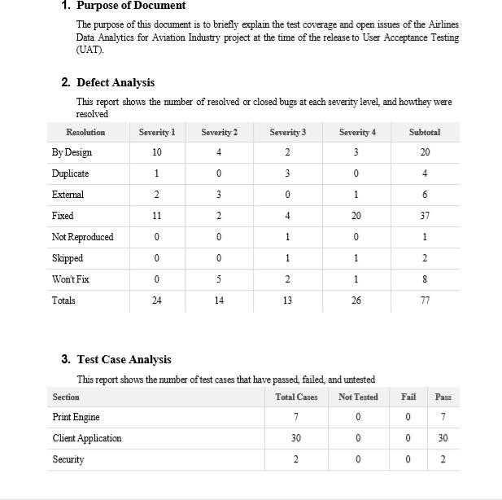

# RESULTS

* 1. **Performance Metrics Model Performance Testing:**

# The project team shall fill in the following information in the model performance testing template.

|  |  |  |
| --- | --- | --- |
| **S.No** | **Parameter** | **Screenshot** |
| **1** | **Dashboard design** |  |

|  |  |  |
| --- | --- | --- |
| **2** | **Data entry** |  |
| **3** | **Data responsiveness** |  |

|  |  |  |
| --- | --- | --- |
| **4** | **Descriptive report of delay analysis** |  |

1. **ADVANTAGES & DISADVANTAGES**

**Advantages**

1. This application helps users predict the delays if they occur.
2. As a result, they can accurately predict these flight delays allowing passengers to be well prepared for the deterrent caused to their journey.
3. Enabling airlines to respond to the potential causes of flight delays in advance to diminish the negative impact.
4. Therefore, predicting flight delays can improve airline operations and passenger satisfaction, which will result in a positive impact on the economy

# Disadvantages

1. The people who are unaware of this application will have no idea about their flight delay unless they have been notified

# CONCLUSION

Flight delays are a major problem in civil aviation. They incur direct and indirect costs, such as maintenance at the gate, extra fees for crew, food service, and lodging. They also affect passenger satisfaction. Flight delay is inevitable and it plays an important role in both profits and losses of the airlines. An accurate estimation of flight delay is critical for airlines because the results can be applied to increase customer satisfaction and the incomes of airline agencies. So, the prediction and analysis of flight delays are of great significance to airlines, passengers, and airports. Predicting delays will help an airport to adjust resource allocations, quickly analyse the causes, and take measures to reduce or eliminate delays. Therefore, It delivers a well-friendly graphical UI and gives a proper delay rate to the users.

1. **FUTURE SCOPE**

There are still deficiencies in this application. Furthermore, this application can be enhanced for allocating various resources to the customers if a delay has occurred and they can also book tickets for their flights through this application.

1. **APPENDIX Source Code: main.py:**

**from flask import render_template,Flask,request import pickle**

**appl=Flask( name )**

**file=open("model.pkl","rb")**

**knn=pickle.load(file) file.close()**

**@appl.route("/", methods=["GET","POST"]) def index():**

**if request.method=="POST":**

**myDict = request.form**

**type1= myDict["elevation_ft"] pred = [type1] res=knn.predict([pred])[0]**

**return render_template('result.html',elevation_ft=type1,res=res) return render_template('index.html')**

**return 'OK'**

**if name == " main ":**

**appl.run(debug=True)**

**temp.py:**

**from sklearn.neighbors import KNeighborsClassifier from sklearn.model_selection import train_test_split import pandas as pd**

**import numpy as np import pickle**

**dt = pd.read_csv(r"C:/Users/Anjana/Downloads/airports.csv")**

**dt = dt.dropna()**

**dt=dt.replace('NaN',0) dt=dt.replace('OC',1) dt=dt.replace('AF',2) dt=dt.replace('AN',3) dt=dt.replace('EU',4) dt=dt.replace('AS',5) dt=dt.replace('SA',6)**

**#feature and target arrays train=dt['elevation_ft'] target=dt['elevation_ft'] train=np.array(train) target=np.array(target)**

**X_train, X_test, y_train, y_test = train_test_split(train,target, test_size = 0.2, random_state=42)**

**knn = KNeighborsClassifier(n_neighbors=5)**

**knn.fit(X_train.reshape(-1,1), y_train)**

**file = open("model.pkl","wb")**

**pickle.dump(knn,file)**

**file.close()**

**index.html:**

**<!DOCTYPE html>**

**<html lang="en">**

**<head>**

**<meta charset="UTF-8">**

**<link rel="stylesheet" href="https://stackpath.bootstrapcdn.com/bootstrap/4.3.1/css/bootstrap.min.css" integrity="sha384-ggOyR0iXCbMQv3Xipma34MD+dH/1fQ784/j6cY/iJTQUOhcWr7x9JvoRxT2MZw1T" crossorigin="anonymous">**

**<title>Airline Delay Prediction</title>**

**</head>**

**<style> body{**

**background-image: url('im1.gif') ; background-repeat: no-repeat; background-attachment: fixed; background-size: cover;**

**}**

**</style>**

**<body>**

**<br><br><br><br>**

**<div class="container">**

**<h1 class="text-center m-3 badge-dark text-w**

**p">**

**Airlines Delay Prediction**

**</h1>**

**<div class="card container" style="width: 65%; ">**

**<div class="card-body">**

**<form action="/" method="post">**

**<div class="form-group">**

**<label for="formGroupExampleInput1">Elevation feet</label>**

**<input type="text"**

**class="form-control" id="formGroupExampleInput1" name="elevation_ft"**

**required**

**/>**

**</div>**

**<center><button type="submit" class="btn btn-dark">CHECK</button></center>**

**</form>**

**</div>**

**</div>**

**</div>**

**</body>**

**</html>**

**result.html:**

**<!DOCTYPE html>**

**<html lang="en">**

**<head>**

**<meta charset="UTF-8">**

**<link rel="stylesheet" href="https://stackpath.bootstrapcdn.com/bootstrap/4.3.1/css/bootstrap.min.css" integrity="sha384-ggOyR0iXCbMQv3Xipma34MD+dH/1fQ784/j6cY/iJTQUOhcWr7x9JvoRxT2MZw1T" crossorigin="anonymous">**

**<title>Delay-Prediction</title>**

**</head>**

**<style> body{**

**background-image: url('im2.gif') ; background-repeat: no-repeat; background-attachment: fixed; background-size: cover;**

**}**

**</style>**

**<body >**

**<br><br><br><br>**

**<div class="container" >**

**<h1 class="text-center m-3 badge-dark text-wrap">Airlines Delay Prediction</h1>**

**<div class="card container" style="width: 50%;">**

**<div class="card-body" >**

**<form action="/" method="post">**

**<div class="form-group">**

**<label for="formGroupExampleInput1">Elevation feet</label>**

**<input type="text"**

**class="form-control" id="formGroupExampleInput1" name="elevation_ft" placeholder="{{elevation_ft}}" required**

**/>**

**</div>**

**<h2 class="text-center text-wrap" >The Delay rate is {{res}} minutes </h2>**

**</form>**

**</div>**

**<center><a href="/"><button type="submit" class="btn btn-dark">Back</button></a></center>**

**</div>**

**</div>**

**</body>**

**</html>**

**GITHUB AND PROJECT DEMO LINK:**

**Github Link: https://github.com/IBM-EPBL/IBM-Project-28531-1660113390**

**Project Demo Link: https://drive.google.com/file/d/12WnBFXjE0EQuwn1RAKYrU4WmBV_ZumKi/view?usp=share_link**